Welcome to the COMBINE working group for standardization of multicellular model descriptions.

News: OpenVT Reproducible Agent-Based Multicellular Model Competition
The Open Virtual Tissues (OpenVT.org) initiative has announced the winners of the 2025 Reproducible Agent-Based Multicellular Model Competition. One model based on CompuCell3D and two models based on the Morpheus modeling framework made it to the podium and were celebrated at the OpenVT Satellite Workshop of the SMB meeting on July 13. The upcoming 2026 round of this competition for promoting Findable, Accessible, Interoperable and Reproducible (FAIR) simulations will be launched here.

Benchmark models
As a community effort, we collect biological benchmark problems and the corresponding representations in alternative modelling formalisms as well as model implementations in specific simulation environments.
For this repository see the COMBINE Multicellular Modelling project

Concepts
The concept for MultiCellML based on SBML Level 3 extensions is summarized here and a prototype to test and run the new language concepts is described here.

Models
The concepts of MultiCellML have already enabled a number of multicellular models that have been shared at four public model repositories.

Events
Please see the sidebar for relevant past and upcoming events.

Hackathon 2019
The 2019 Hackathon has taken place in Dresden, for details see here.

Coordination
Lutz Brusch, TU-Dresden
Martin Golebiewski, HITS Heidelberg

Funding
TU Dresden, CIDS, ZIH
OSCARS
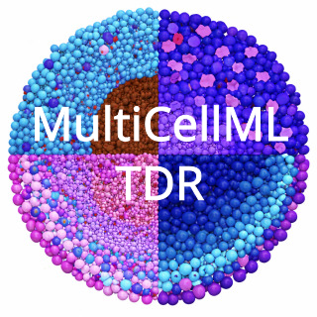MultiCellML-TDR

