Prototype implementation of MultiCellML concepts in MorpheusML
We are using MorpheusML to test the concepts of MultiCellML, e.g. spatial scoping that allows to model coupling between properties of multiple individual cells that can be dynamically generated (e.g. through cell division) and destroyed (e.g. through apoptosis) but use their own copies of the same entities (biochemical molecules) with the same symbol name (irrespective of the computational index of each individual cell). The individual property values are then internally resolved for each computed individual cell and its interaction partners as explicitly specified by Reporter and Mapper constructs.
In MorpheusML, also the Cellular Potts Model for cell shape dynamics can be defined and parametrized (besides PDE, ODE, CA) and two software frameworks, Artistoo and Morpheus, are available to simulate MorpheusML models. Extensions to further simulation frameworks are in progress.
For more details on Artistoo, see the Artistoo Converter and Homepage.
For more details on Morpheus, see the Morpheus Homepage.
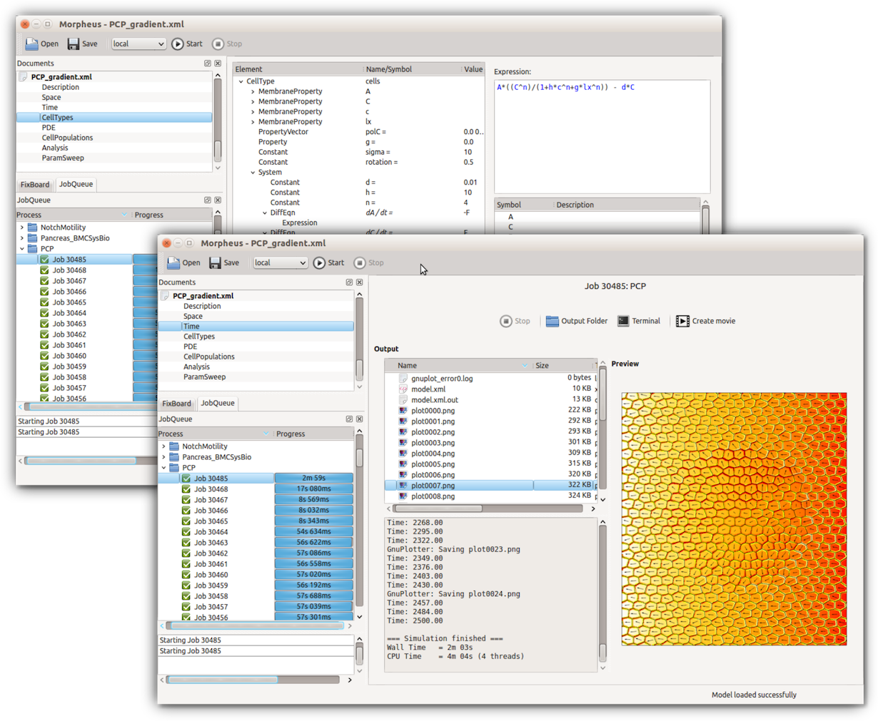GUI of Morpheus

