Hackathon 2019
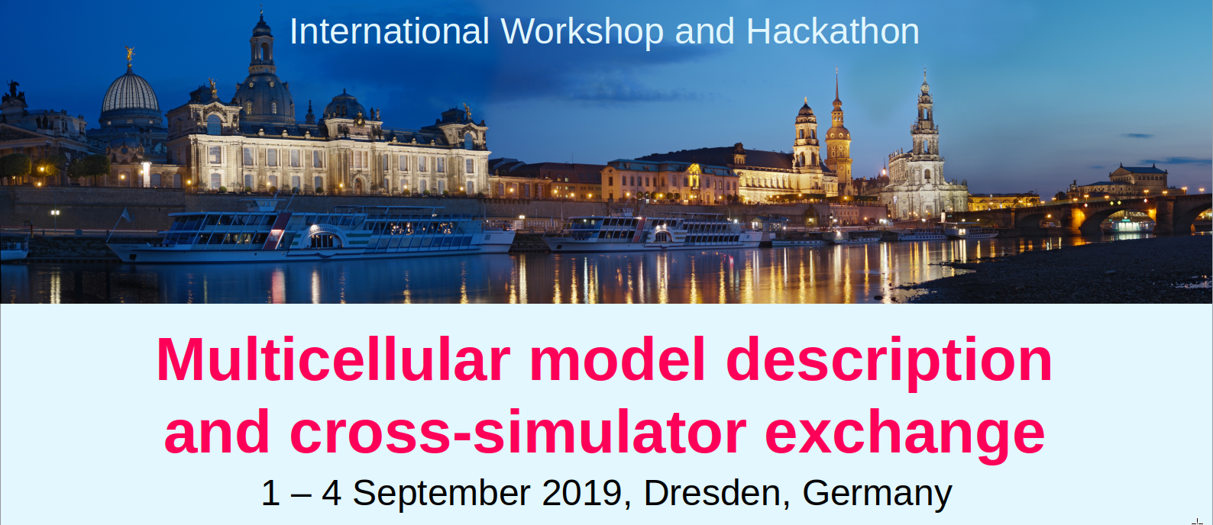 Hackathon 2019

Aim
Multicellular spatial models have become an essential tool in quantitative biology and multiple model formalisms (incl. rule-, energy- or force-based cell and tissue mechanics) and simulation frameworks coexist. Progress towards software interoperability and reproducibility requires a novel model description language and conversion library, complementing SBML. Building on the community‘s practical experiences with multiple formalisms and simulators, we aim at (1) defining the concept for a multicellular language while simultaneously (2) exploring automated model conversion between (closely related, e.g. CPM-supporting) simulators using the language prototype.
This defines two tracks (1. Language and 2. Converter) with joint talks and parallel working sessions.

Agenda

Sunday, 1 Sept. – Social activities
For those arriving early/Saturday, we‘ll organise a hiking trip through and onto the spectacular sandstone cliffs in the nearby national park or a guided city tour (depending on weather).
The Conference Dinner on Sunday evening will mark the official start.

Monday, 2 Sept. 9AM-6PM – Workshop
We‘ll start with joint talks and discussions on lessons learnt from SBML, recent advances in simulators, efforts to reproduce simulation studies as well as declarative model interfaces in specific simulators.
2PM Public keynote lecture by James A. Glazier
Discussion groups for the parallel tracks. Joint dinner.

Tuesday and Wednesday, 3-4 Sept. 9AM-5PM – Hackathon
Joint discussions and parallel working sessions for drafting the language concept and specification (proposals exist) in the Language track as well as hands on coding and testing the Converter software (prototype exists in C++).
Please bring your laptop with your simulator installed.

Confirmed invited speakers (frameworks)
- James A. Glazier, Indiana University (CompuCell3D)
- Martin Golebiewski, HITS gGmbH Heidelberg (COMBINE)
- Tim Johann, IfADo Dortmund (TiSim)
- Matthias König, Humboldt-University Berlin (SBML)
- Jochen Kursawe, University of St Andrews (Chaste)
- Andy Somogyi, Indiana University (Mechanica)
- Jörn Starruß/Walter de Back, TU Dresden (Morpheus)

Contact
Lutz Brusch, TU Dresden
lutz.brusch@tu-dresden.de

Venue
Technische Universität Dresden
Andreas-Pfitzmann-Bau (of the computer science faculty)
Nöthnitzer Str. 46 , 01187 Dresden, Germany
Tram: line 3 takes you from the city center (e.g. tram stop “Hauptbahnhof Nord” in front of the Pullman hotel) to tram stop “Münchner Platz” (stop number 4 from Pullman), then walk 5min uphill along Georg-Schumann-Straße to get to the green-glass building “Andreas-Pfitzmann-Bau”. For the full tram network see this map by the operator DVB.
Taxi: number is from outside/roaming (0049 351) 211 211.
Electricity: Germany serves 230 V at 50 Hz with socket (CEE 7/3) and plug (CEE 7/4) termed “type F” or “Schuko” (foto).
Please bring an appropriate adapter for your laptop and phone chargers.
Wifi: is provided throughout the venue but is best used with an "eduroam"-enabled account. In any case, we'll get you online.

Contact
Lutz Brusch
Center for Information Services and High Performance Computing at TU Dresden
Email: lutz.brusch@tu-dresden.de
Web: https://imc.zih.tu-dresden.de
Phone: 0049 351 46338553

